MATERIAL LIST
Name | Picture | Quantity | Website | Company | Description | Price €
Wood panel | 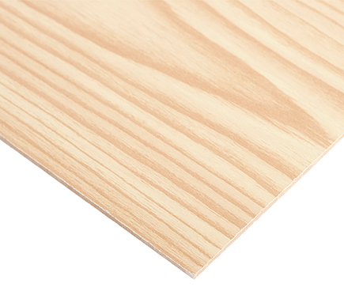 | 4 | Not on website, is in the Leroy merlin store in matosihnos | Leroy merlin | Panel contraplacado  5mm 1200x600 | 21.16€
Wood struts | 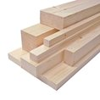 | 1 | Not on website, is in the Leroy merlin store in matosihnos | Leroy merlin | Balsa wood struck  10X10x1000mm | 1.39 €
The structure of the shelter in the scale model is going to be made by wood, because is cheaper than steel and aluminium and easier to modelate. We check the different types of wood in the market, and we decided to make it with balsa wood. We decided to use a softwood because is easier to modelate and it’s a perfect material for doing modelling. Another good thing about this type of wood is that is lightweight.

screws | 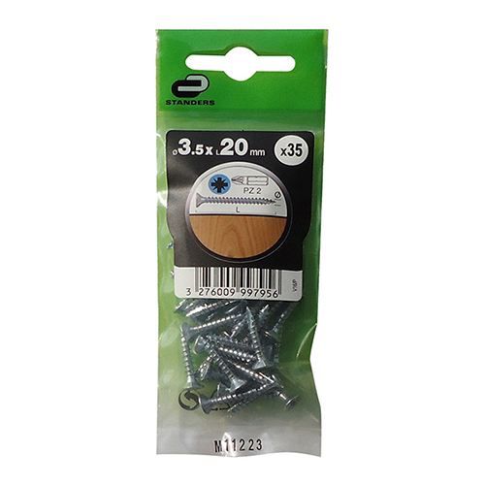 | 1 | http://www.leroymerlin.pt/Site/Produtos/Ferragens/Ferragens-de-fixacao/Parafusos/15680770.aspx | Leroy merlin | 35 Parafusos  POZIDRIV 3.5X20 | 0.99 €
We need the screws for connect the roof and the hinges.

PC | 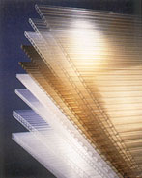 | 1 | http://pt.mouser.com/ProductDetail/Phoenix-Contact/1934874/?qs=sGAEpiMZZMsDddcp1dBDJOrXMrFmZFLlqQAEbthOj0A%3d | Phoenix Contact | Colour: transparent Espessura: 6 m/m  We only need 1m² | ? (Not more than 12€ x m2)
We are using PC for covering the shelter.

Hinges | 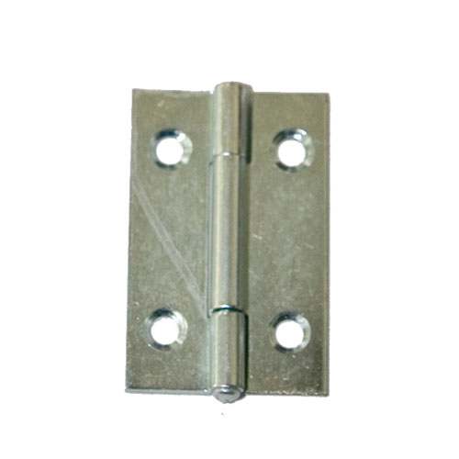 | 3 | http://www.leroymerlin.pt/Site/Produtos/Ferragens/Ferragens-para-moveis/Dobradicas/14945756.aspx | Leroy merlin | 3 dobradiças retangulares  ZINCADO 25X18mm | 5.67€
The connections with movement like the windows and the doors, are going to be connected by hinges.
Silicone | 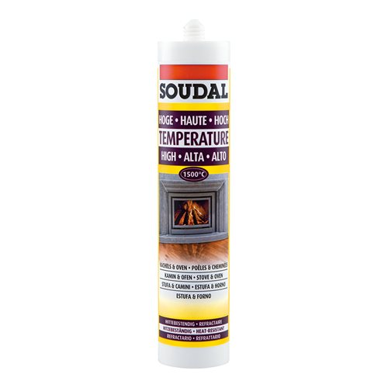 | 3 | http://www.leroymerlin.pt/Site/Produtos/Pintura/Isolamento-e-impermeabilizacao/Silicones/17105774.aspx | Leroy merlin | Massa Refratária é uma massa de alta qualidade, resistente a temperaturas elevadas (até 1500⁰C). | 8.97€
Double side Tape | 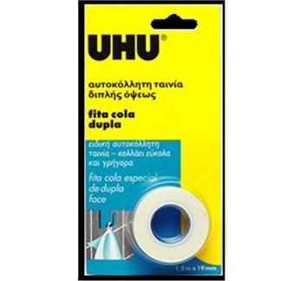 | 3 | http://www.aki.pt/Fita-cola-dupla-face-P40687.aspx#.VTTdwCF_Oko | UHU | Fita dupla face 1.5m x 19mm | 12.87€
VELCRO | 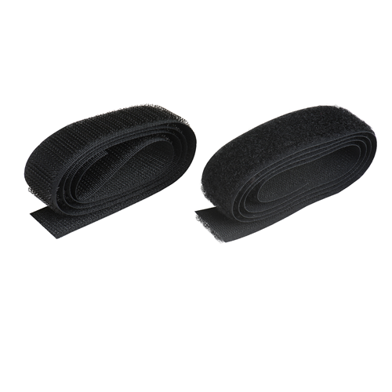 | 2 | http://www.leroymerlin.pt/Site/Produtos/Ferragens/Ferragens-de-fixacao/Cordas-e-correntes/16756194.aspx | LEROY MERLIN | Fita velcro  60cm 20m COSER | 3.98€
The connections with movement like the windows and the doors, are going to be connected by hinges. And to close the windows and the door we are going to use Velcro
PLASTIC FILM | 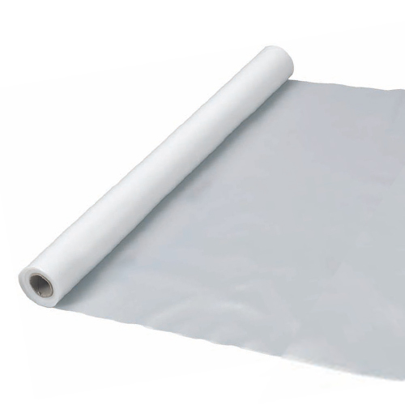 | 2m2 | http://www.leroymerlin.pt/Site/Produtos/Madeiras/Pavimento/Bases-para-pavimento/15115975.aspx | Leroy merlin | Filme  PVC AXTON | 1.98€
The windows have to be lighter than the other panels, that’s why we’re covering with plastic film.

Glue sticks | 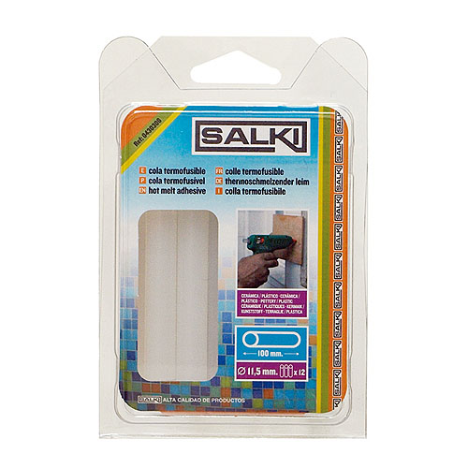 | 3 | http://www.leroymerlin.pt/Site/Produtos/Ferramentas/Ferramentas-de-mao/Ferramentas-de-fixacao/566293.aspx | Leroy merlin | Cola para madeira  SALKI 12 UNIDADES | 8.07€
Cost of construction materials:
77.08€
Arduino UNO | 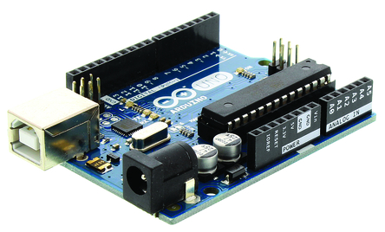 | 1 | http://pt.rs-online.com/web/p/kits-de-desarrollo-de-procesador-y-microcontrolador/7154081/ | Arduino | Motherboard for our control sustem | 21.10€
LCD display | 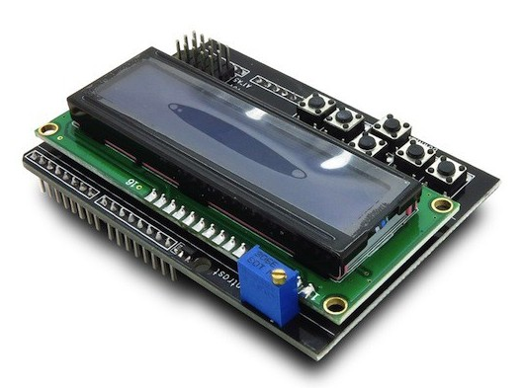 | 1 | http://www.inmotion.pt/en/lcds/1017-lcd-shield-for-arduino.html | ITeadStudio | Allows to display all data to the user | 11.01€
Sensor | 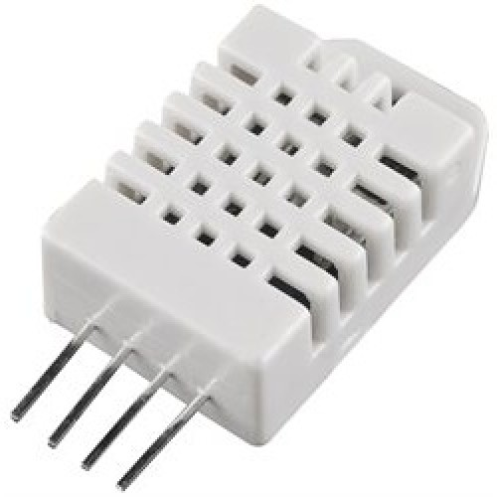 | 1 | http://www.inmotion.pt/en/adafruit/982-dht22-temperature-and-humidity-sensor-extras.html | Adafruit | Measures temperature and humidity. | 13.47€
Power supply | 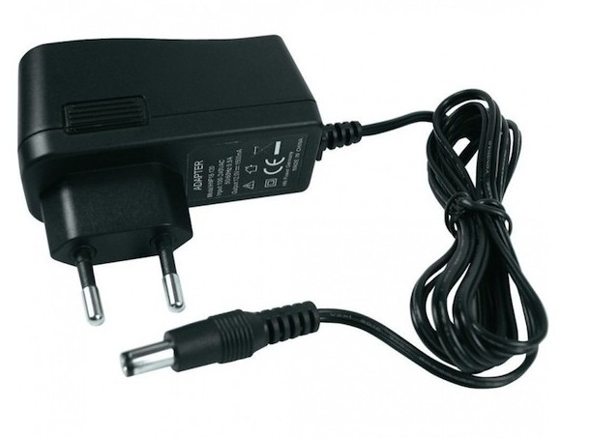 | 1 | http://www.inmotion.pt/en/power-supply/758-power-supply-12vdc-15a-eu.html |  | Providoes power for whole system | 12.24€
Cost of electronic materials:
57.82€
 |  |  |  |  |  | Total cost ( electronic + construction materials): 134.9€

